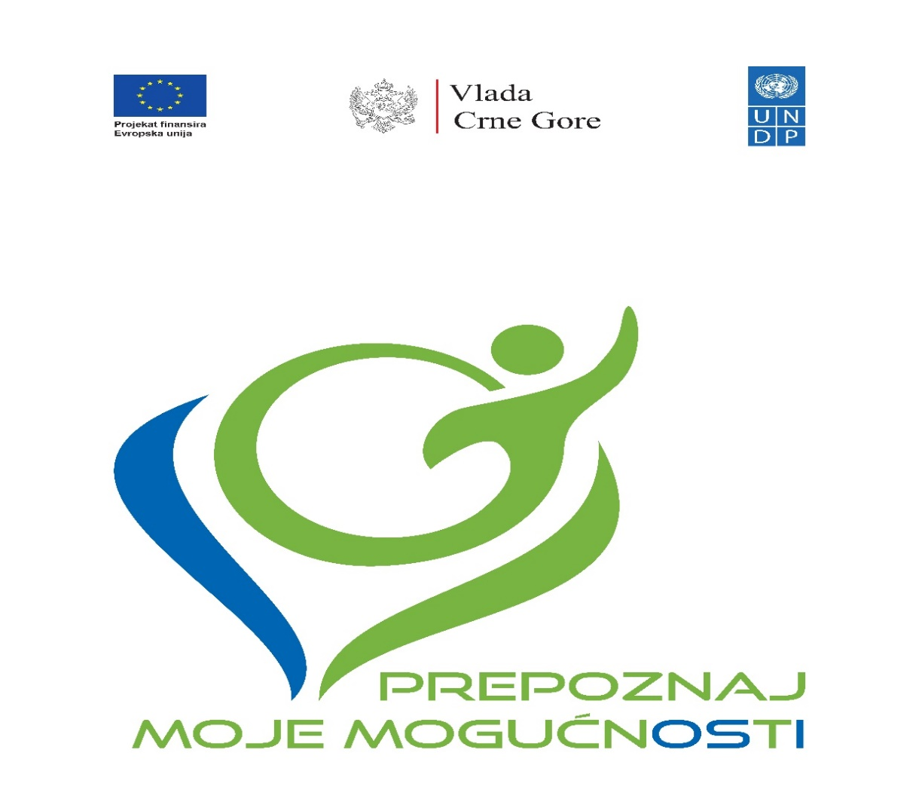

Project “Reform of National Disability Determination System”

Second Progress Report
October 2021 - September 2022

Podgorica, November 2022

Table of contents

Summary of the Action 4
Results achieved 5
Activities carried out during reporting period 11
DIFFICULTIES ENCOUNTERED AND MEASURES TAKEN TO OVERCOME PROBLEMS AND EVENTUAL CHANGES INTRODUCED 21
Visibility and Communication 23
Summary of resources deployed during the reporting period 26
Work Plan for the upcoming period 27

List of Abbreviations

DEU | Delegation of European Union
OPD | Organisation of Persons with Disabilities
MFSS | Ministry of Finance and Social Welfare
MoLSW | Ministry of Labor and Social Welfare
UN Convention | UN Convention on the Rights of Persons with Disabilities
IWG | Intersectoral Working Group established by the MFSS
SC | Steering Committee
MED | Ministry of Economic Development
MJHMR | Ministry of Justice, Human and Minority Rights
IPH | Institute for Public Health
UNDP | United Nations Development Programme
CfP | Call for Proposal

Summary of the Action

The project enforces a comprehensive, structural reform of the national disability determination/assessment system. The aim of the reform is to set up a single body for disability determination/assessment and establish uniform national criteria and methodology in line with the human-rights based approach. The project is recognized as a priority area by Program of Economic Reforms (2021-2023).
This is a complex reforming venture which includes five sectors: social protection, employment, pension and war veterans, education and health. All the disability entitlements (various cash transfers and social services, disability pensions, employment and professional rehabilitation, education entitlements, various subsidies, etc.), in these sectors for about 50,000 citizens and their families, directly depend on design of disability determination system.
The overall objective is to fully reform the overall national disability assessment/determination system for more just, equal and easier access to rights to all kinds of cash benefits and services for persons with disabilities, in line with the national positive legislation and ratified UN Convention on the Rights of Persons with Disabilities (hereinafter: UN Convention). It will be enforced through technical assistance for the development of new (legal and institutional) national disability determination system, capacity building of all line sectors and their professionals and civil servants and raising public awareness among specific target groups and general population.
The specific objective of the project is the reform of the national Disability Assessment and Determination System. The reform will enable persons with disabilities to enjoy fair treatment, easier and equal access to all social security entitlements and better social inclusion prospects, in line with the UN Convention on the Rights of Persons with Disabilities.
Upon establishing of the new system, persons with disabilities will have more equitable access to rights, while it will also enable better monitoring of the potential misuses of social and other benefits and services. New definition of disability was adopted by act of ratification of the UN Convention on the Rights of Persons with Disabilities (2009).

Results achieved

During reporting period following result were achieved, with reference to the Logical Framework:
 | Results chain | Indicators | Baseline (incl.ref.) | Current value Reference date: July 31, 2019. | Targets (incl. reference year) | Sources and means of verification | Results
Overall objective: Impact | Overall objective:  More just, equal and easier access to all rights (cash benefits and services) for persons with disabilities | New assessment and determination system set in place and functioning | 2017:  New assessment and determination model in place | 2019:  New assessment and determination model in place | 2023:  New nation level human rights model developed and applied within a new unified system of assessment and determination | Government reports:  Action Progress Report  National Strategy on PWD implementation progress reporting by MLSW | The dynamic of project implementation was impacted by several reasons including COVID, political instability and frequent changes of the governments that vastly influenced sound engagement and decision-making processes. Very intensive coordination and communication among representatives of relevant stakeholders, coordinated by UNDP, greatly contributed to overcoming these challenges.  Government (all the concerned sectors) and OPDs are actively engaged in the reform of the system.
Specific objectives: Outcomes | Specific objective:  National Disability Determination System reformed.  Result 1. Development and adoption of new criteria for disability determination.  Result 2. Institutional rightsizing reorganization – by downsizing of current 30 commissions to one unique Commission. | New functionality-based model criteria developed and adopted, at national level  The national, unique Commission/Institute legally established and performing its scope of work | 2017:  Separate assessment and determination procedures taking place in different sectors within 30 commissions | 2019:  Separate assessment and determination procedures taking place in different sectors within 30 commissions | 2023:  New assessment and determination system with sophisticated Information System for cases processing – put into operation | Government reports  Laws and by-laws adopted in the Parliament and published in the Official Gazette of Montenegro  Action Progress Reports.  National Strategy on PWD implementation progress reporting by MLSW
Outputs | 1.1. Multi-sectoral Task-force work group established and functioning | 1.1.1.  No. of meetings with written minutes records | 2017:  No multi/cross sectoral coordination mechanism dealing with assessment and determination  Baseline: 0 | 2019:  No multi/ cross sectoral bodies dealing with assessment and determination is in place  Current value: Task-force group established. | 2022:  Intersectoral Working Group established  Target: nine meetings of Task-force group in the course of the Action | Official decision on the establishment of the Multi-sectoral Task-force work group (MLSW)  Reports, meeting minutes, progress track records and decisions | Intersectoral working group established in May 2021. Six meeting of IWG held.
 | 1.2. Comprehensive, unified List of Impairments, List of Functional Limitations and national uniformed Criteria developed | 1.2.1.  Comprehensive list available  1.2.2 New national uniform criteria available | 2017:  Different lists and criteria applied in the six sectors for disability assessment and determination  Baseline: 0 | 2019:  Different lists and criteria applied in the six sectors for disability assessment and determination  Current value: 0 | 2022:  Comprehensive, unified List of Impairments, List of Functional Limitations and national uniformed Criteria developed Target: both docs adopted. | Government reports.  Official Gazette of Montenegro | Five Task force groups established by the IPH work on developing unified criteria for disability assessment. Two segments of methodology to be used for the assessment of impairment and functional capacity are completed (List of Impairments, List of Functional Abilities and WHODAS questionary). Development of third segment of methodology that will be focused on needs assessment is under development and it is expected to be completed by the end of 2022.
 | 1.3. New law(s) and bylaw(s) adopted | New law(s) and by-laws enforced. | 2017:  There are 6 laws and 27 bylaws regulating the area  Baseline: 0 | 2019:  There are 6 laws and 27 bylaws regulating the area  Current value: 0 | 2022:  Target: revisions of the 6 laws and 27 by-laws. The new law and by-laws on assessment and determination criteria & establishment of Commission adopted | Official Gazette of Montenegro | Developed a draft version of the Law on Unified Disability Assessment, presented and submitted to the MFSS, for further proceeding. There is an ongoing public discussion, while adoption of the Law is expected in December 2022.
 | 2.1 Commission established, staffed and supported | 2.1.1. Number of professional and administrative staff hired  2.1.2. Number of assessments procedures carried out monthly  2.1.3. Number of issues reported and resolved  2.1.4. Number of consultative meetings held | 2017: No Commission/Institute  2.1.1. Number of professional and administrative staff hired  Baseline: 0  2.1.2. Number of assessments procedures carried out monthly  Baseline: 0  2.1.3. Number of issues reported and resolved  Baseline: 0  2.1.4. Number of consultative meetings held  Baseline: 0 | 2019: No Commission/Institute  2.1.1. Number of professional and administrative staff hired  Current value: 0  2.1.2. Number of assessments procedures carried out monthly  Current value: 0  2.1.3. Number of issues reported and resolved  Current value: 0  2.1.4. Number of consultative meetings held  Current value: 0 | 2022: Commission/Institute established and functioning  2.1.1. Target: 30 staff professional and administrative staff hired  2.1.2. Target: 300 assessments procedures carried out in the first 3 months  2.1.3. Target: 5 issues reported and resolved in initial month  2.1.4. Target: Four consultative meetings held in initial 2 months | By-law on institutional establishment and systematization of the workplaces/staffing  Project progress reports  Staff performances data from the Information System of the Commission  Consultative meetings minutes and obligatory conclusions
 | 2.2. Premises adapted and equipped | 2.2.1. Number of premises adapted  2.2.2. Number of pieces of equipment procured and delivered | 2017: No Commission/Institute  2.2.1. Number of premises adapted  Baseline: 0  2.2.2. Number of pieces of equipment procured and delivered  Baseline: 0 | 2019: No Commission/Institute  2.2.1. Number of premises adapted  Current value: 0  2.2.2. Number of pieces of equipment procured and delivered  Current value: 0 | 2022: Commission/Institute established and functioning  2.2.1. Number of premises adapted  Target: 1  2.2.2. Number of pieces of equipment procured and delivered  Target: 150 | Official Gov.'s Decision on the premises allocation  Technical works hand-over documentation and reports  Equipping | Only in October 2022, MoLSW identified possible premises, but the decision on its allocation is still pending. This issue and its impact on project’s dynamic has been discussed with the Ministry on several occasions, both by UNDP and EUD, including sending formal notes. Since possible premises are identified, official decision is expected by the end of the 2022. Once decision is official, UNDP will start with implementation of the activity.
 | 2.3. Civil servants trained for application of the new assessment and determination system | 2.3.1. Number of civil servants and experts trained  2.3.2. Number of civil servants and expert participating in study visits | 2017: Civil servants and experts not trained to apply the new assessment and determination criteria  2.3.1. Number of civil servants and experts trained  Baseline: 30  2.3.2. Number of civil servants and expert participating in study visits  Baseline: 10 | 2019: Civil servants and experts not trained to apply the new assessment and determination criteria  2.3.1. Number of civil servants and experts trained  Current value: 0  2.3.2. Number of civil servants and expert participating in study visits  Current value: 0 | 2023: Functionality (ability) based assessment trainings  Tailor-made trainings in interpretation of all the medical sub-specialties criteria for professional assessors  Target: 50 civil servants and experts trained (~50% women)  Two study visits conducted  Target: 10 participants | Training programs and materials developed  Participation lists records  Study visit reports with lessons learned
 | 2.4. PWD and wider public duly informed about the new assessment and determination system | 2.4.1. Number of campaign activities implemented  2.4.2. Number of topics covered  2.4.3. Number of organizations involved  2.4.4. Number of persons targeted by the campaigns | 2017: Several PWD associations supported to advocate and lobby for the new model. PWD, caregivers and wider public not acquainted with the new model  2.4.1. Number of campaign activities implemented  Baseline: 0  2.4.2. Number of topics covered  Baseline: 0  2.4.3. Number of organizations involved  Baseline: 0  2.4.4. Number of persons targeted by the campaigns  Baseline: 0 | 2019: Several PWD associations lobbying for the new model.  Wider public not acquainted with the new model  2.4.1. Number of campaign activities implemented  Current value: 0  2.4.2. Number of topics covered  Current value: 0  2.4.3. Number of organizations involved  Current value: 0  2.4.4. Number of persons targeted by the campaigns  Current value: 0 | 2023:  2.4.1. Number of campaign activities implemented - Target: 10  2.4.2. Number of topics covered - Target: 6  2.4.3. No. of PWD associations involved in the campaigns – Target: 5  2.4.4. The five sectors’ scopes of work covered and over 100.000 persons targeted by the campaign. Target: 100.000 persons | Campaigns documentation  Campaigns records & statistics | Organized launch event with all relevant stakeholders and massive participation of OPDs. Event was attended by 62 participants and covered by reports in 13 media.  Distributed grants to 5 NGOs for implementation of projects, as per the C&V Plan.  So far, 23 campaign activities was implemented by 6 NGOs, covering at least 10 topics relevant for people with disabilities. 6 OPDs were included in implementing campaigns. So far, around 150k persons have been targeted by the campaigns.  Also, UNDP produced and distributed 3 human interest stories, broadcasted in prime time on RTCG in the morning program, radio stations and all web portals. Also, stories were published on UNDP EURASIA, further increasing visibility of the action internationally.
 | 2.5. Information System developed and implemented | 2.5.1. System developed, tested, staff trained & put into operation.  2.5.2. Number of institutions connected to the information system  2.5.3. Number of new entries into the system  2.5.4. Number of PWD with personal records in E-Registry | 2017: Information System not in place  2.5.1. System developed, tested, staff trained & put into operation.  Baseline: 0  2.5.2. Number of institutions connected to the information system.  Baseline: 0  2.5.3. Number of new cases entries into the system  Baseline: 0  2.5.4. Number of PWD with personal records in E-Registry  Baseline: 0 | 2019: Information system not in place  2.5.1. System developed, tested, staff trained & put into operation.  Current value: 0  2.5.2. Number of institutions connected to the information system  Current value: 0  2.5.3. Number of new entries into the system  Current value: 0  2.5.4. Number of PWD with personal records in E-Registry  Current value: 0 | 2023: IS in place.  2.5.1. System' Acceptance Test verified.  2.5.2. Interoperability established with four IS of other institutions  2.5.3. On average 200 cases processed monthly in the initial 3 months through the Information System  2.5.4. All new Commission staff trained to operate in new IS.  Social welfare staff trained to operate by new procedure in Social Card – ISWS. | Information System with E-Registry of PWD developed and put into operation
 | 2.6. Piloting of the new assessment and determination system performed | 2.6.1. Number of individual cases determined  2.6.2. Number of procedures analyzed  2.6.3. Analytical report with recommendations available  2.5.4. New system Impact assessment | 2017: New system not in place  2.6.1. Number of individual cases determined.  Baseline: 0  2.6.2. Number of procedures analyzed  Baseline: 0  2.6.3. Analytical report with recommendations available  Baseline: 0  2.5.4. New system Impact assessment  Baseline: 0 | 2019: New system not in place nor the Information system  2.6.1. Number of individual cases determined.  Current value: 0  2.6.2. Number of procedures analyzed  Current value: 0  2.6.3. Analytical report with recommendations available  Current value: 0  2.5.4. New system Impact assessment  Current value: 0 | 2023:  2.6.1. All the work-procedures analyzed (application, processing, individual decisions issuance & referrals) to all six sectors – 40 cases.  2.6.2. One analytical report with recommendations produced  2.6.3. One impact assessment report produced | Pilot Phase Analytical report with adjustments recommendations  Impact assessment report

Activities carried out during reporting period

Project team was established
Ms. Aleksandra Višnjić as a Programme Manager and Ms. Dušanka Milaković as the Project Finance and Administration Officer were appointed by United Nations Development Programme (hereinafter: UNDP). Ms. Sanja Zindović was recruited as a Project Coordinator through competitive UNDP recruitment procedures. This recruitment process lasted longer than was expected as the position was readvertised due to the lack of quality applications. Ms. Zindović joined the Project Team on March 1, 2021.
Four consultants were recruited
Seven consultants (four local and three international) were recruited during the reporting period. All positions were advertised on UNDP website and recruited through UNDP recruitment procedures.
International consultants:
Ms Lidija Hrastić Novak was the best qualified candidate for the position of Lead Advisor. Namely, among 15 applications, 3 met qualifications and requirements from the published ToR. Upon the interview, and based on the overall assessment, applicant’s working experience, financial offer and matching with the Terms of Reference, the Evaluation Panel concluded that Ms. Lidija Hrastić Novak is the best qualified for the position.
We received 6 applications (after the advertisement deadline extension) for the position of Advisor for development of national unified methodology and criteria for disability assessment. Only one candidate, Ms Eos Martinac, met all qualifications and requirements from the published ToR, and therefore was selected for the position.
Following the initiative of the organizations of persons with disabilities (hereinafter: OPDs), it has been agreed to create a glossary of terms for the purpose of this project and for the new legislative framework that is under development. Since DPOs do not have a unified position on the meaning of several disability-related important terminology, the Project Team engaged an international expert Mr Damjan Tatić to prepare proposal of the glossary in line with UN CRPD. Mr Tatić is an eminent expert on the rights of persons with disabilities, their protection and promotion, co-author of the UN Convention, and a member of the CRPD Committee in two terms (2011-2018). The cost for Mr Tatić is included under the Activity Development and adoption of new criteria for disability determination – International Consultant. This amendment does not affect the main purpose of the Action, such as its objectives, strategy and priority areas, and the financial impact is limited to a transfer within a single budget heading (variation less than 25%).
Local consultants:
Ms Mirjana Ivanović was selected as the best candidate for the position Communications Consultant. Among 27 received applications, 6 applicants met all qualifications and requirements from the published ToR. The UNDP Evaluation Panel concluded that Ms Ivanović’s qualifications and experience fully match the requirements of this consultancy.
The evaluation panel received 15 applications for the position Lawyer, out of which 3 were shortlisted. Upon the interview, and based on the overall assessment, applicant’s working experience, financial offer and matching with the Terms of Reference, the Evaluation panel concluded that Ms. Ljubinka Vukajlović was the best qualified for the position. Due to health issues, Ms. Vukajlovic resigned from the position in April 2022. Therefore, the new recruitment process has been conducted.
As a result, Ms. Snežana Jonica is engaged for the position in June 2022. She is highly experienced in drafting laws, by-laws and other legal decrees, through her extensive work experience in the Parliament of Montenegro, Parliamentary Assembly of Council of Europe and Port of Kotor. Also, she has a relevant experience related to advocating for the rights of people with disabilities, including being a member and chair of the PACE Sub-Committee on Persons with Disabilities and Inclusion, as well the PACE Committee for Equality and Anti-Discrimination.
In order to develop regulatory impact assessment analysis (RIA) UNDP engaged Mr. Branko Radulović. His extensive experience includes among other, producing impact assessments for various policy options in the region and Montenegro, including co-authoring RIA Manuals in Montenegro.
Establishing Steering Committee
The start of the project was postponed on two occasions. Initially, reasons were complicated epidemiological situation caused by COVID-19 pandemic and change of the Government and the structure of the line ministries. The additional postponement was caused by the long-lasting process of appointment of Government members of the Project Steering Committee. Eventually, Deputy Prime Minister appointed the following members of the Steering Committee (hereinafter SC) only on April 2nd, 2021:
- Ana Rašović, Advisor to the Deputy Prime Minister, General Secretariat of the Government;
- Nina Milović, Head of the Directorate for Health Care, Ministry of Health;
- Tamara Milić, Head of the Directorate for Preschool and Inclusive Education, Ministry of Education, Science, Culture and Sports;
- Janko Odović, State Secretary, (Deputy Amela Orahovac), Ministry of Finance and Social Welfare.
Additionally, Ministry of Economic Development (hereinafter: MED) and Ministry of Justice, Human and Minority Rights (hereinafter: MJHMR) appointed their representatives in SC:
- Ms Jevrosima Pejović, Acting Director-General of the Directorate for Labour and Employment in the MED;
- Ms Aleksandra Popović, Acting Director-General of the Directorate for Protection and Equality of Persons with Disabilities in the MJHMR
Mr Miguel Magro Gomez, Task Manager was appointed by the Delegation of European Union to Montenegro (hereinafter: DEU), while UNDP representative in SC is Mr Miodrag Dragišić, UNDP Assistant Resident Representative in Montenegro.
Also, based on the conducted public call for NGO representative, Ms Marina Vujačić has been appointed as a member of the SC. Ms Vujačić is Executive Director of the Association of Youth with Disabilities of Montenegro (UMHCG) and prominent activist for the promotion and protection of rights of persons with disabilities.
Due to another change of the Government and line officials, the line MLSW is addressed to appoint new SC members.

Steering Committee Meetings
The first SC meeting was held on April 20, 2021 in UN Eco House. The SC appointed Ms Ana Rašović as a chairperson and agreed that, on behalf of the Deputy Prime Minister, she will initiate the appointment of member of SC to represent MED. More details on the meeting can be found here.
The second SC meeting took place on July 23, 2021 in UN Eco House. Alongside the presentation of implemented and discussion on planned activities, members were informed on the initiative of MED for establishing one institution for the needs of disability assessment and professional rehabilitation. More details on the meeting can be found here.
Result Area 1: Development and adoption of new standardized, unified, national functionalities/abilities-based criteria for disability determination for all the six sectors dealing with disability assessment: social welfare (cash transfers/benefits and services), pensions, war veterans, employment, education and health.
Activity 1.1. Establishing Intersectoral Working Group to lead/steer the overall process
Ministry of Finance and Social Welfare (hereinafter: MFSS) established an Intersectoral Working Group (hereinafter: IWG) for the project implementation in May 2021. The composition of IWG was the subject of discussion at the first SC meeting. Namely, SC members agreed that instead of being composed of lawyers only, as initially proposed, this Working Group should also include representatives of other professions. Therefore, IWG counts 23 members from all relevant sectors and institutions including healthcare, education, social welfare, employment and OPD representatives. MFSS published public call for 4 OPD representatives in IWG, though only 2 OPDs delegated their representatives.
The first meeting of the IWG was held on May 31, 2021, in the hotel Hilton. It has been organized as an inception workshop, where members were informed about the Project goals, key activities, work plan and potential risks. The meeting was attended by two consultants engaged by UNDP. Ms Lidija Hrastić Novak, Lead Expert presented Croatian experience and lessons learnt with the reform of disability determination system. Ms. Ljubinka Vukaljović, the lawyer presented the first draft of the Law on Unified Disability Assessment. Presentations were followed by an extensive discussion on challenges and potential risks that may be faced in the process. For more information on the meeting please see meeting minutes and list of participants.
Ms Hrastić Novak prepared draft Analysis of existing disability determination system with the recommendation for further actions in June 2021. This is a working document which will be amended during different phases of the reform process.
The second meeting took place on October 7, 2021, in MFSW, where both international experts, Ms Lidija Hrastić Novak and Eos Martinac participated. They explained process of developing legal framework, including Law on Unified Disability Assessment and Decree on Methodology of Disability Assessment. Ms. Eos Martinec presented work of five working groups established by the Institute for Public Health (hereinafter: IPH) who are developing methodology for disability assessment. Once developed, the methodology will be an integral component of the Decree on Methodology of Disability Assessment. Meeting minutes can be found here.
The third meeting was held on October 28th, 2021, where Draft version of the Law was discussed. The key issues discussed during the meeting were terminology, methodology and procedure for initiating assessment. For more information on the meeting please see meeting minutes and list of participants.
The fourth meeting to discuss a new version of the Draft Law was organized on March 16th, 2022. The key issue discussed was to what extent sectors will be able to make decisions based on the expert opinion issued by the Institute for disability assessment. In terms of initiating assessment, IWG decided that process will be initiated by the person instead of sectors. For more information on the meeting please see meeting minutes and list of participants.
On July 29th, 2022, the fifth meeting of IWG, now summoned by MLSW, was held in UN Eco House where Ms. Snežana Jonica was introduced as the new UNDP consultant. She presented an amended version of the Law. The IWG agreed upon the planned dynamic of future work on the draft Law. For more information on the meeting please see meeting minutes and list of participants.
A.1.2. Development of (1) Comprehensive list of medical conditions and illnesses and (2) new functionality based Uniform national criteria for determining functional capabilities
UNDP signed a Standard Letter of Agreement with the Institute for Public Health (hereinafter: IPH) in May 2021 to support the complex process of developing Methodology for Disability Assessment/Determination. IPH established five Task Force groups in line with types of impairments (physical, mental, intellectual, sensory impairments) recognized in the UN Convention and additionally for autism spectrum disorder. Some Task Force groups are split into smaller units due to their complexity, focusing on for children and adults’ specifics. As assessment of children with disabilities is particularly sensitive, each Task Force group includes specialists who directly work with children with disabilities and the OPD of parents of children with disabilities. The work of each group is coordinated by the IPH coordinator, and continuously supported by UNDP.
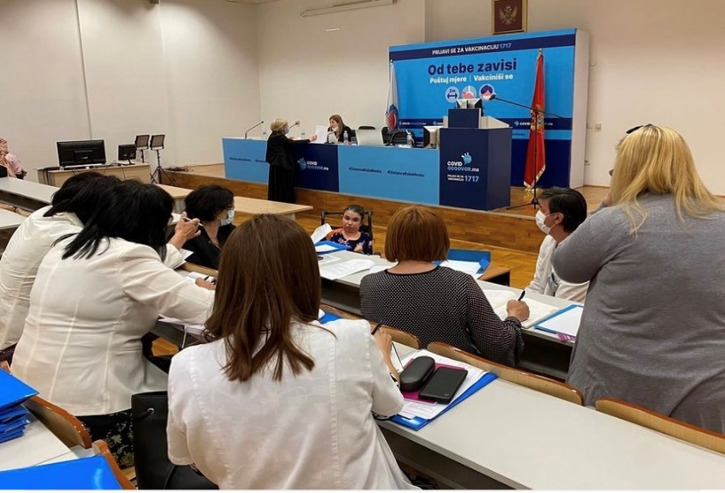
As the project aims to develop a national Methodology for Disability Assessment in line with social and human rights-based model of disability assessment promoted by the UN Convention on the Rights of Persons with Disabilities, the groups include experts from all relevant fields, including experts from the existing assessment and determination system, medical doctors from various fields of medicine (ophthalmologists, audiologists, internists, neurologists, orthopaedics, gynaecologists, psychiatrists, paediatricians, occupational medicine, surgeons, physiatrists); representatives of other occupations involved in the care for persons with disabilities (psychologists, social workers, physiotherapists, work therapists). In line with slogan Nothing about us without us, IPH announced and re-announced call for 12 OPD representatives including associations of parents of children with disabilities, yet only 7 representatives applied and are actively taking part.
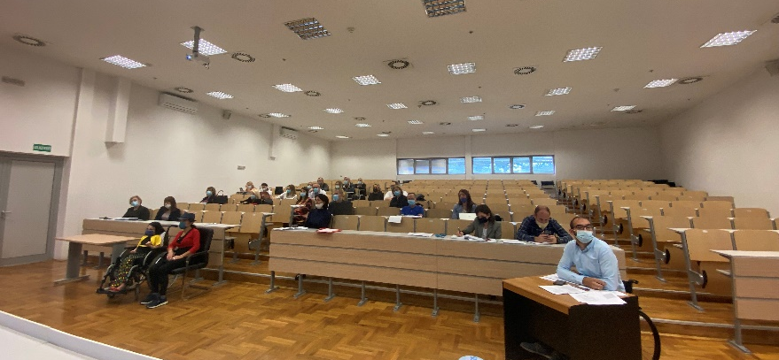
The CRPD concept of disability is relational, it recognises the interaction between impairment and barriers which hinder their ‘full and effective participation in society on an equal basis with others’. Therefore, methods and criteria for disability assessment/determination should be designed in a way to reflect on all important segments of disability: impairment, functioning and the most important – interaction with barriers and the individual’s support needs.
Even though widespread ratification of UN CRPD has resulted in attempts of some states to adopt assessment systems that are in line with the CRPD and revise their definitions, the lack of CRPD-specific guidance either for developing disability assessment mechanisms or for determining disability, resulted in having only elements of assessment mechanisms which can be regarded as good practice in several states. Therefore, UNDP team has conducted detailed research of existing practices in Europe, attended several international webinars and had multiple consultations with the UN Committee on the Rights of Persons with Disabilities, other UN agencies dealing with disability issues, UNDP disability network, various international experts and states that are currently implementing similar processes, in order to support the process of developing assessment mechanism in line with UN Convention. Consequently, due to complexity of the topic, lack of good sample model tested, and most important challenges with shifting perspective/paradigm from medical to human rights and social concept of disability, implementation of this activity requested longer period than initially planned by the project and far more demanding.
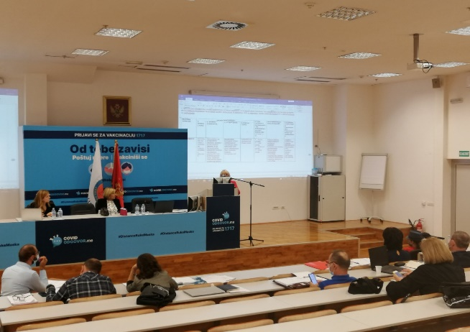
So far, two segments of methodology have been developed fully developed: List of Impairments and List of Functional Limitations. The Taskforce groups were guided by two international standardized tools developed by WHO - International Classification of Disease (ICD) and International Classification of Functioning, Disability and Health (ICF). Furthermore, in order to provide a full scope of information on how a person is functioning (within the last 30 day) in his/her environment, task force groups made a decision for administration of WHODAS 2 questionnaire. It is a practical, generic assessment instrument that can measure health and disability and most importantly it is directly linked to ICF. However, since this instrument is found not to be optimally adequate for the assessment of children, the Task-force groups invested an additional effort and managed to develop a specific questionnaire for children.
A questionnaire will finally enable future disability assessment experts to have a proper necessary insight into individual perspective on one’s impairment and barriers included in the decision-making process. This is an important step in transitioning from the medical to social model of disability, where a person with disability is not just a spectator of the assessment process but is actively engaged in it, providing inputs about his or her daily life and creating a support system that fits his or her needs. All developed instruments, although guided by relevant international instruments and practices, are entirely tailored to the local context, circumstances and needs.
Person with Disability official status will be determined based on combined total score of these two lists. Still, together with the stakeholders it is agreed upon that it is necessary to develop an additional 3rd segment in order to assess needs of people with disabilities.
The third segment of disability assessment/determination criteria is assessment of individual’s Support Needs so called Needs' Assessment. Work on this questionnaire is still ongoing and is expected to have draft by the end of the year. The Needs Assessment findings is considered to be essential for future evidence-based planning since based on actual PWD needs, development of support services and other policy measures should be planned and provided. More photos from meetings of Task Force groups can be found here.
A.1.3. Creation and adoption of new normative framework, encompassing law and bylaws
As elaborated above, initially Ms. Ljubinka Vukajlović was engaged as Legal Expert for supporting developing of a new legal framework for disability assessment/determination. With 27 years of experience as a legal expert in the national Secretariat for Legislation of Montenegro, she has extensive experience with drafting, reviewing, aligning, and analysing drafts and bills of laws, by-laws, and other regulations, in the area of social and child protection, employment, pension and disability insurance, war veteran sectors. She prepared an Analysis of the existing legal framework with a proposal for amendment of existing legal norms. Also, she prepared a zero draft of the Law on Unified Disability Assessment, that has been presented to IWG and with her support, several iterations of comments and suggestions were addressed. The draft law was prepared and submitted to the MFSS, for further proceeding, but as OPDs suggested that there is space for further considerations and improvements, IWG continued work on the draft law. MFSS informed UNDP that the adoption of the law is postponed for the third quarter of 2022.
Due to health reasons, Ms. Vukajlović resigned from the position in April 2022. Therefore, the new recruitment process was initiated. The position was readvertised due to the lack of qualified candidates, thus the whole recruitment process lasted longer than it was initially expected. As a result, Ms. Snežana Jonica is engaged for the position in June 2022. She is highly experienced in drafting laws, by-laws and other legal decrees, through her extensive work experience in the Parliament of Montenegro, Parliamentary Assembly of Council of Europe and Port of Kotor. Also, she has relevant experience in advocating for the rights of people with disabilities, including being a member and chair of the PACE Sub-Committee on Persons with Disabilities and Inclusion, as well as the PACE Committee for Equality and Anti-Discrimination.
Eventually, work on the draft Law continued in July 2022. With several iterations of consultations, joint and individual meetings and addressing suggestions of different sectors and OPDs, including the meeting with the line Minister of LSW, the final version of the Law was adopted by the IWG in November. The process of public discussion started on November 21st and will last for 20 days. Upon addressing comments to be received in the course of the public discussion, the draft Law along with the accompanying acts (RIA and Explanatory Notes) will be submitted to the Secretariat for Legislation, to the Government and finally to the Parliament of Montenegro for adoption.
The dynamic of preparing the draft Law has been significantly impacted by several factors. Alongside COVID which largely slowed the pace of the reform, political instability and frequent changes of the governments vastly influenced sound engagement and decision-making processes. Even the focal point person for the project changed three times. This instability strongly influenced the work of institutions and commitment of key stakeholders (sectors) to the process. Especially, alignment with traditionally rigid pension sector positions as well as employment sector, required long consultations and negotiations. Additionally, in August 2022, digital infrastructure of public administration suffered a cyber-attack. Communication with institutions was stalled for more than a month, and to date is not fully recovered, including e-mail communication that made it whole even more difficult and exhausting.
As presented under Activity 1.1., SC members proposed an extension of the composition of IWG. Therefore, due to its wide composition (23 members), Project Team formed a compact Task Force Team to support developing of the first draft of Decree as part of new normative framework. Task Force Team is composed of one representative of each relevant sector, who are lawyers with extensive practical experience with implementation of the existing legal framework. Its compact composition enables a higher level of efficiency and responsiveness. All documents developed by the Task Force Team are to be duly presented, discussed and adopted by IWG. Due to the above presented difficulties with setting draft law, work on the Decree has been paused for a couple of months. Namely, before continuing work on the Decree it was necessary to set the direction of the reform and key definitions since there have been significant alternations during the time. As the draft Law has been adopted and currently is a subject of public discussion, Task Force Team is now in position to continue work on the Decree, other bylaws and on the Expert Opinion template.
The consultant for developing Regulatory Impact Analysis (RIA) has been engaged in May 2022. RIA is prepared in close consultation with numerous representatives of all relevant sectors and local level (education sector) and based on received financial inputs for each sector. Alongside the situation analysis, it includes elaborated possible solutions as well as a detailed overview of costs of setting new institutional framework for three years period. RIA to be officially submitted by the MLSW to Ministry of Finance for approval.
Result Area 2: Institutional rightsizing and reorganization
Activity 2.4. Promotion, information sharing and education
In line with the guiding principles of the project Nothing About Us Without Us, ensuring adequate representation and effective participation of OPDs throughout the process is crucial for its legitimacy. This principle is reflected in all implemented and ongoing activities. So far, three calls for in total 17 OPDs representatives in different project entities have been published. OPD representatives and people with disabilities are members of SC, IWG, five Task Force groups established by IPH, Taskforce Team. Yet, the number of OPD representatives who are engaged is still below the expected.
Following the approval of SC, the first Call for Proposals (furthermore CfP) for the allocation of grants for the implementation of promotional and educational activities was published on June 29th, 2021. Information about the CfP was published on UNDP website, daily newspapers and circulated via CRNVO E-mail list to all NGOs registered in Montenegro. In order to provide detailed information about the call, application procedure and selection criteria to potential applicants, an online consultative session has been organized on July 6, 2021. The total eligible amount of funding under this CfP was 50,000 EUR.

The priority areas addressed with this CfP were presented and discussed with OPDs during the Launch Conference organized on June 2nd, 2021. More info on the CfP can be found here.

By the set deadline, UNDP received proposals from eight NGOs. The evaluation process was two-phased. As a result of the preliminary evaluation, five out of eight applicants scored more than minimal eligibility threshold of 70 points and therefore were shortlisted for the second evaluation phase. Before the final decision was made, a number of consultative meetings were organized with the applicant NGOs, and they re-submitted improved project proposals. Under the first CfP 49,542 EUR was allocated for five project proposals. For more info on the evaluation process please refer to Evaluation Meeting Minutes.
UNDP signed Law Value Grant Agreements with five NGOs in September. Four selected grant recipients are OPDs. CGO is the only NGO that does not have the status of an OPD but has extensive experience in advocating for the rights of people with disabilities and partners with an OPD for implementation of the project. Duration of contracts varies from 4 to 12 months, while budget ranges between 7,000 to 12,000 EUR.
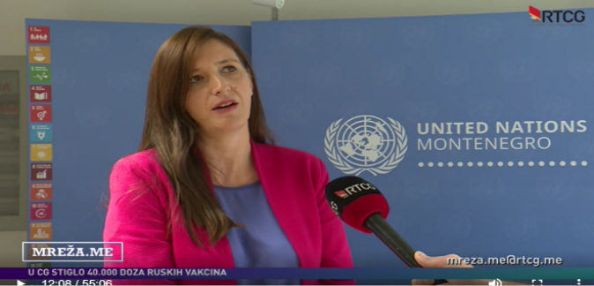
Contract signature was followed by a press release about distribution of grants, published on UNDP website and EU Info Centre, as well as in multiple media. Also, Programme Manager, Ms. Aleksandra Višnjić participated in the TV format MREŽA.ME at RTCG where she presented grant scheme. Press clipping with links to all materials can be found here.
Key activities implemented under 1st CfP:
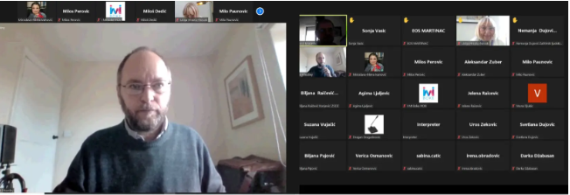
Initiative of Youth with Disabilities of Boka (IYDB): The overall objective of the project EduAction for Disability Rights was to contribute to increasing the inclusion and respect of the rights of persons with disabilities in Montenegro. Webinar Developing a Rights-Based System of Disability Assessment for 32 members of working groups of the MFSW and the Institute for Public Health (7 male and 25 female) and other participants, was organised on October 1, 2021. The Webinar was led by internationally reputable Prof. Mark Priestley, Professor of Disability Policy at the School of Sociology and Social Policy at the University of Leeds in the UK, and co-author of the ANED report "Disability Assessment in European States ANED Synthesis Report", that provides an analysis of the disability assessment system in 34 European countries. The Webinar enabled participants to acquire knowledge, first-hand advice and insight into good and bad practices from other countries with many years of experience in this field and provided participants with perspective on how CRPD-compliant disability assessment should look like. The webinar is highly appreciated by the participants who often refer to it and the follow up materials. Activity also have had a positive impact on engagement of consultants and members of the working groups for disability assessment reform. The material is published on IYDB YouTube channel, different social platforms, shared with members of all working groups and via OPD mailing list. More info on webinar can be found here.
IYDB organized four workshops for PWDs, who are using services of different public institutions: Home for the Elderly “Grabovac“ in Risan, Special Hospital for Psychiatry Kotor, "Komanski most" Resource Center for Hearing and Speech “Dr Peruta Ivanović“. In total, 43 PWDs (25 male and 18 female) participated in the workshops. The workshops addressed topics of the rights of PWDs, with special focus on elderly with disabilities, people with mental illness, intellectual disabilities, hearing and/or speech impairments, depending on the target group of each workshop. More info about workshops can be found here. Also, information about workshops was shared via social platforms and Radio Kotor reaching approximately 4k people.
Also, under this project, IYDB provided legal support by initiating proceedings and sending initiatives for changes of legal framework and practice based on the request of 17 people. Media and awareness raising campaign included publishing 12 announcements and press releases before and after the implementation of each project activity, communication with local and national media and 3 guest appearances in them, social media campaign, preparation, and publishing 10 educational content and reactions to local and state institutions, which are important for exercising the rights of PWDs. Campaigns reached around 11k od people with at least 325 interactions. More info about the campaign can be found here.
Union of the Blind of Montenegro: The general objective of the project Strengthening the Social Engagement and Possibility of PWDs on the Principles of Equality and Dignity was to raise the level of awareness of wider community in Montenegro about the rights and opportunities of PWD in accordance with a rights-based model. Grantee implemented four wide range media campaigns covering various topics like correct terminology related to people with disabilities, social and human rights-based approach to disability, gender equality, anti-discrimination, equality and accessibility of information; employment, salary subsidies, hiring an assistant, workplace adjustment, so-called workplace equipment, choice of jobs, diversity of job choices conditioned by (im)possibility of acquiring knowledge, sport. Media campaigns included publishing of five video tutorials, four video spots, ten personal stories, and in addition to initially planned, they prepared and published two podcasts. By reaching 85k people on different social platforms, campaign reached four times more people than initially planned. Project strongly supported raising awareness of the wider community about the rights, opportunities, potential of PWDs and shifting paradigm from medical to right-based approach to disability. More info about campaigns with links to all material can be found here.
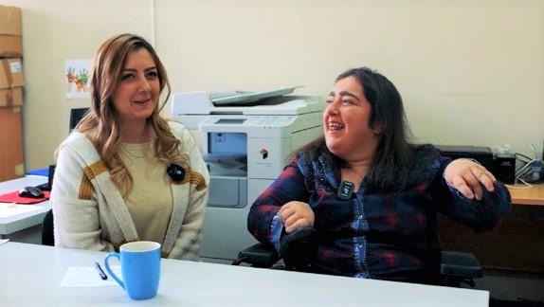
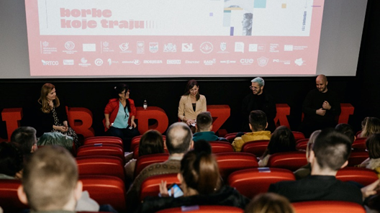
Centre for Civic Education(CCE): The overall objective of the project EqualABILITY was to contribute to achieving equality of persons with disabilities (PWD) in Montenegrin society. To achieve that, they implemented raising awareness campaign about the abilities, possibilities and capabilities that PWDs have and how to contribute to their social inclusion. Campaign One day with me included production and promotion of three short videos that from human stories perspective, present everyday life of persons with disabilities, proving that people with disabilities can successfully be presented in usual engaging manner that attracts audience and at the same time raises awareness about challenges they are facing. Videos emphasize their abilities, they are portrayed as ordinary citizens who happen to have a disability, without sensationalizing the disability part of their lives. Project contributed to raising awareness and understanding of the media professionals about disability and professional standards in investigating and reporting on people with disabilities to contribute to the promotion of human-rights approach of disability and prevention of discrimination through production of Handbook for inclusive media reporting and Competition for the best journalistic story about PWDs. The competition for the best journalistic story about people with disabilities showed that journalists need to be stimulated to report more in-depth about the group, as unfortunately this activity has warned that a very small number of articles are being written about PWDs. Finally, during the FAST FORWARD Human Rights Film Festival Montenegro, organized by CCE, film “Restless”, which promotes rights and lives of people with psycho-social disabilities, the most disadvantaged under this group, was screened and followed by a panel discussion. Surprisingly well reactions of public, both to the film and the subsequent panel discussion, have shown that a lot of prejudices or simply misunderstandings remain, and that psychosocial and intellectual disabilities are not enough present in public discourse. Approximately, the project reached around 25k people, through various communication channels and platforms. A detailed list of all media content and materials produced under this action can be found here.
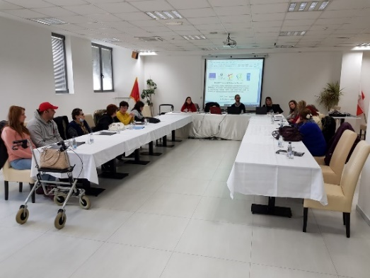
Ekvivalent: Within the project Turn on, this is important for you! eight educational workshops, in eight different towns in Montenegro were organized for persons with disabilities, their parents/guardians and representatives of OPDs. All activities were followed by a wide range media campaign reaching at least 30k people. 84 people who participated at trainings were directly informed about the ongoing reform, their rights, UN Convention on the Rights of Person with Disabilities and importance of shifting focus from medical to rights-based approach to disability. Detailed list of all media content and photos under this action can be found here.
Association for assistance to persons with disabilities Niksic: The overall goal of project Good information leads to good results was increasing awareness of representatives of various entities about the rights, obstacles and opportunities of persons with disabilities in Nikšić. Campaign included workshops for informing and educating representatives of local institutions, citizens, people with disabilities and their family members on the position of people with disabilities and their rights, but also about the new system of the disability assessment/determination. Campaign was implemented through the four workshops, round table, two focus groups, publication and distribution of a brochure and through close cooperation work with media. Approximately this project reached 2.5k people. Detailed list of all media content under this action can be found here.
Set consisted of Project Implementation Manual and Communication and Visibility Guidelines was prepared by Project Team and distributed to all grantees. UNDP Project Team continuously supported them throughout the projects implementation and conducted series of meetings with NGOs, in order to meet project teams and provide additional clarifications about the process.

DIFFICULTIES ENCOUNTERED AND MEASURES TAKEN TO OVERCOME PROBLEMS AND EVENTUAL CHANGES INTRODUCED

Due to the complicated political and epidemiological situation in the country, start of the project was postponed on two occasions. Initially, the reasons were related to the complicated epidemiological situation caused by the COVID-19 pandemic and change of the Government and the structure of the line Ministries. The additional postponement was caused by the long-lasting process of appointment of the Government members of the Project Steering Committee. To mitigate and compensate for potential delays of planned activities, Project Team intensified work on establishing all relevant multi-sector task force groups immediately upon appointment of SC, coordinated their work and therefore in first year managed to stay in line with the work plan.
During the launch event, OPDs initiated development the Glossary of Key Terms (not envisaged by the Action) they found necessary for the Project’s implementation in terms of the new legislative framework. Discussion on definitions of disability-related terms lasts for more than a decade in Montenegro. To support this important process and endorse the OPD initiative to define and include the terminology list in the Law on Unified Disability Assessment, UNDP organized and coordinated an extensive series of discussions with and between OPDs. Since OPDs do not have a unified position on the meaning of several important terms, Project Team decided to engage international expert Mr Damjan Tatić to prepare a proposal of the glossary in line with UN CRPD. Prepared proposal of the glossary was presented to OPDs, but they haven’t managed to reach consensus among themselves. Therefore, this issue was resolved by IWG, and definitions included in the draft law, are a result of consensus between sectors and OPDs. This is an important breakthrough as those definitions will significantly impact changes in numerous laws still having definitions that are product of a medical approach to disability and often some of them contain derogatory terms like inability etc.
The dynamic of project implementation during the second year was significantly impacted by several factors. Alongside COVID, political instability and frequent changes of the governments vastly influenced sound, agile engagement and decision-making processes. The situation proved to be especially difficult with such a multi-stakeholder setting the Action entails. This instability strongly influenced not only the operational work of institutions, but it also affected commitment of the key stakeholders (sectors) to the process. Frequent changes of head of sectors and other officials required investing additional endeavours of UNDP team into their briefings and influenced process of creating strong bonds between different stakeholders for obtaining support for the reform. The commitment as a risk is recognized in the Action' Risk Assessment but in such a setting it escalated.
Parallel process of reaching consensus on terminology and definitions, both between OPDs on one side and OPD and sectors on the other, and "management" of this discussions, additionally slowed down the set pace of developing legal framework. Also, alignment with traditionally rigid, purely medically based pension sector as well as employment sector, required long, exhausting consultations and negotiations. This is especially relevant considering that the Law on Unified Disability Assessment will cause significant amendments of both pension and employment sector legislative framework and their system laws. Eventually, in August 2022, digital infrastructure of public administration suffered a cyber-attack. Communication with institutions was stalled for more than a month, and to date is not fully recovered. In addition, employment sector was not able to generate data on their disability assessment related costs needed for RIA preparation.
Also, as envisaged in the Action Risk Assessment, there is the issue of review/revision of persons who are currently disability entitlements rights holders (be it in pension, employment, social sectors, etc.). Currently there are about 55.000 of right holders that multiplied with an average of 3-4 family members makes half of the country population to be directly affected by the reform – turning this issue into a political one. Therefore, this decision also slowed down the project implementation pace, being a difficult one especially for the Government in technical mandate.
Another major project delivery obstacle (also recognized in the Risks analysis) is allocation of premises for Institute for Disability Determination by the Government. UNDP timely (starting from the 1st SC meeting), officially requested allocation of the premises in order to timely provide all the necessary procurement processes. The request is repeated both in official correspondence and in the meetings with ex and current highest officials with no official response on the matter. However, there seems to be a breakthrough since the MLSW has only in October 2022 identified that approx. 250m2 of the Centre for Professional Rehabilitation premises (currently not occupied) could be allocated for the Institute. Still, an official decision of the Government is pending and therefor UNDP in such a situation is not in position to start preparing procurements related to the premises adaptation works and equipping.
To lessen impact and compensate for of all above presented circumstances on project implementation dynamic, Project Team organized numerous meeting and briefings with all the sectors and MLSW officials. Also, the time when work on normative framework was slowed due to changes of governments and cyber-attack, work on Methodology development was intensified. UNDP team conducted detailed research of existing practices in Europe, consultations with UN CRPD, various international experts and states that are currently implementing similar processes, in order to support process of developing assessment mechanism in line with the UN Convention. As a result, two segments of the Methodology are developed, while third segment is underway. Considering its importance, complexity, lack of guidance and good practices, we believe that decision to invest additional efforts and time into developing CRPD compliant methodology will strongly support the reform impact and reaching its overall objective of having more just, equal and easier access to rights to all kinds of cash benefits and services for persons with disabilities, in line with the national positive legislation and ratified UN Convention on Persons with Disabilities. The stage of implementation is also in details considered and discussed with the Human Rights Protector Office which from the Action design stage, follows and supports the reform.
Also, in order to increase visibility of the Action and raise awareness on its importance, especially during the period of governments transition, UNDP team intensified communication of the Reform through production of three human interest stories that where distributed by multiple communication channels and generated positive feedback by both institution and general public. Also, on regular basis, EU Task Manager was updated on status of project activities.
Finally, the diverse communication approaches are nurtured and existing in the work of the Government and UNDP. Occasionally, these represented a challenge in implementing the project activities in terms of time, delivery and expectations from all of the counterparts. Very intensive coordination and communication among representatives of these institutions greatly contributed to overcoming this challenge.
Therefore, as discussed in the meeting with Ms. Liselotte Isaksson, Head of Sector – Civil Society and Social Inclusion in European Delegation and Task Manager, considering all the difficulties presented, it is already clear that there will be a need for the extension of the Action, which will be requested in line with EU procedures, three months prior to contract extension.

Visibility and Communication

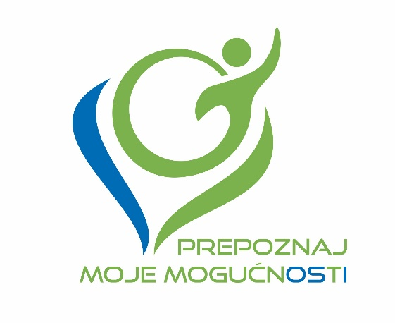
In April 2021, Communication and Visibility Plan for the project was adopted and it envisages different advocacy activities with OPDs. At the beginning of the project, the slogan Prepoznaj moje mogućnosti and logo of the project were designed. Key communication messages were developed and different communicators for distinct areas covered by this project were recognized and listed, so we have them ready in case the necessity for specific communication arise.

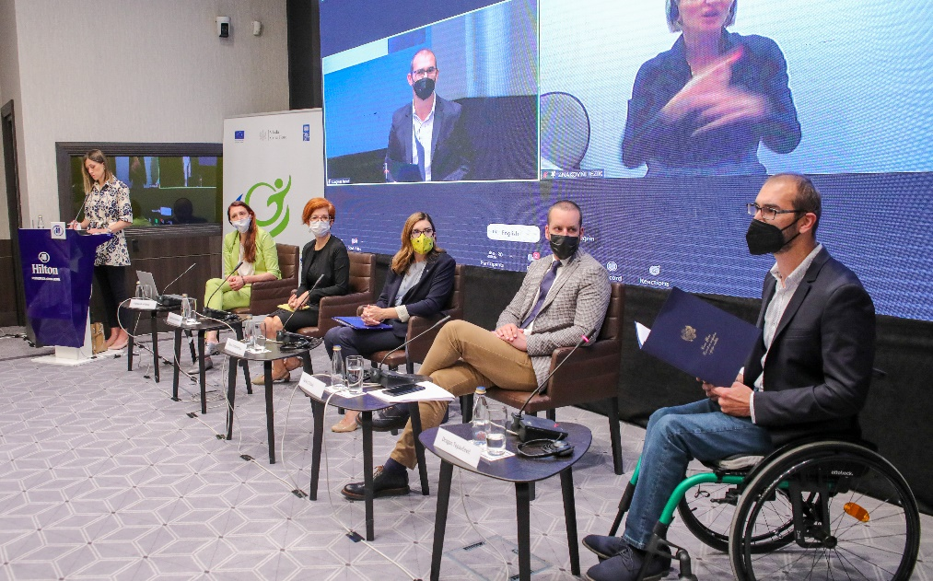
The launching Conference Reform of National Disability Determination System – Recognize my (dis)Abilities was organized and successfully delivered on June 2nd, 2021. The gathering was opened by the State Secretary at the Ministry of Finance and Social Welfare Mr Janko Odović, EU Ambassador to Montenegro Ms. Oana Kristina Popa and UNDP Resident Representative for Montenegro Ms. Daniela Gasparikova. Opening addresses were closed by social worker Mr. Dragan Tepavčević who emphasized the importance of this reform from a perspective of person with disability. The event was organized in a hybrid format due to imposed COVID-related measures. First panel was dedicated to presentation of the Project and attended by representatives of all relevant sectors, institutions and OPDs representatives. The second panel Cooperation with non-governmental organizations (NGOs), was devoted OPDs. Ms. Mirjana Ivanovic presented Communication and Visibility Plan, grant scheme and discussed previously developed themes that would be covered by Call for Proposals. DPO representatives suggested developing a glossary of terms relevant for this Project. In total 62 participants attended Conference, 26 in Hotel Hilton, while 36 joined via Zoom platform. Simultaneous translation into sign language has been provided. For more info on event please refer to press clipping and photos.

As an additional communication tool particularly important during COVID pandemic, UNDP created Disability System Reform mailing list with more than 80 email addresses of all relevant DPOs and their representatives. Those tools are regularly used for communication of all important activities and distribution of information to OPDs.

In line with C&V Plan, the first call for grants was developed and published in media and communicated via the CRNVO network and UNDP mailing list. More on grants under Activity 2.4. Alongside the Communication and Visibility Plan for the Project, the separate C&V plan is developed for the activities implemented by NGOs, financed through grants. This measure allowed better coordination of activities, avoiding their overlapping, and therefore resulted with better media coverage and public reach of the activities.

Although initially planned for the end of 2022, publishing of the second call for grans is postponed for the first quarter of 2023. Namely, due to all setbacks with developing the legal framework as earlier elaborated and considering the intention of having OPDs as the main promoters of new disability assessment system, rescheduling the second call for grants was rational. Only when new methodology and procedures are in place, its adequate promotion will be possible. Therefore, considering the current dynamics of activities on developing normative framework, this activity is postponed for the first quarter of 2023.
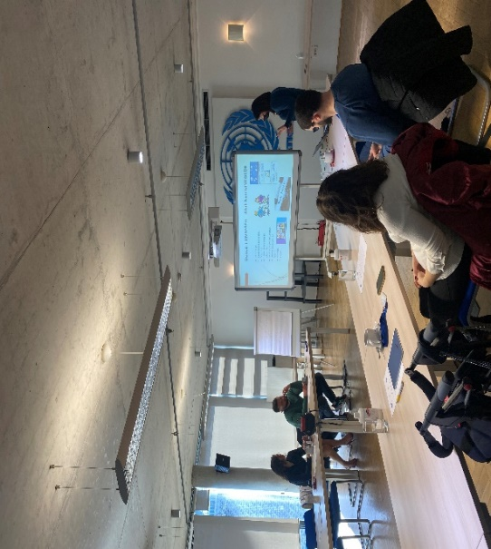
A round table will be organized in the course of public discussion for the draft Law. It aims to support public discussion and enable all interested public to actively participate in the process of creating a new legal framework. It is particularly important for people with disabilities and will allow Ministry to directly address some of the questions and concerns related to the reform. The discussion will be opened for media who will be invited, therefore will additionally support the visibility of the action.

During the consultations with NGOs, they stated interest and willingness to participate in the UNDP organized workshop that would tend to enhance their communication skills. Hence, the training was organized in UN Eco building in February 2022 and delivered by two communication specialists. Training was attended by 6 representatives of 4 NGOs. Participants had an opportunity to learn about various communication tools and techniques, how to create campaign and how to manage their accounts on different social platforms. The feedback from the training was very positive. More information about training can be found here.
In order to improve visibility of the action and raise public awareness on how complex and discriminatory existing mechanisms for disability assessment are, UNDP produced and published three human interest stories. Three people with disabilities shared their experience with disability assessment procedures, the obstacles they faced on their, often complicated, journey to exercising their rights.
Stories show the systemic issues that are faced from the perspective of a child, young woman, and young man with disabilities. A ten-year old Balša learns Braille, plays chess, and rides a scooter with a warm, broad smile.
Slađana Dakić, an assistant costume designer, talks about her struggles to find and keep a job and her frustration with long procedures to get adequate hearing aid.
A young man with intellectual disability, Ismar Ramović is thankful the environment at the souvenir-making company where he works is supportive. Finally, all stories send an important message about the reform and how, once enrolled, new system will positively influence life of people with disabilities. All three stories followed by video stories as well were broadcast on RTCG, in prime time, in the Morning program, by radio stations (Homer and Titograd), and are published by all portals and on social platforms. Links to press clipping for this activity can be found here.

Also, UNDP Istanbul Regional Hub combined those three stories into one published on UNDP EURASIA website, therefore, further increasing visibility of the action internationally. The link to their story can be found here.

Implementation of the project activities and C&V plan is ongoing, and it is closely followed by UNDP Project Team and Communication Consultant.

Summary of resources deployed during the reporting period
During the reporting period 323,639.73 USD were spent out of 559,603 USD (the first and the second pre-financing instalment). The financial Progress report is enclosed as Annex 1 while a List of Legal Commitments is enclosed as Annex 4. Since the condition of utilising 70% of last pre-financing instalment is still not met, the request for next pre-financing payment will be postponed for 2023. Once the expenditure reach set target, UNDP will prepare new report and request the payment.
There were some changes in recording expenditures under the budget category Project Management, budget position National Personnel. First refers to changes of UNDP contractual modalities for national personnel. Therefore, depending on the contractual model used, in accordance with UNDP operational procedures, expenses are recorded under UNDP account codes: 61200 (National personnel – Fixed Term Appointment) or 71400 (Service contract (SC) for individuals - National Personnel Service Agreement). Under the budget line National Personnel, the approved budget envisages 10% of costs for the Communication Officer will be charged from account 61200. However, since the Communication Officer is SC holder, our system records this cost under 71400 instead. Therefore, this change refers only to accounting procedures (changes of accounting code within the same budget line) and it does not affect the main purpose of the Action, nor it has a financial impact on the approved budget.
Second change refers to cost at the position of Project Manager. Namely, considering slowed dynamic of project implementation due to reasons elaborated above, UNDP reduced costs for Project Manager for nine months to 50% within the second year of Project implementation. This measure will contribute to generating savings for possible contract extension.
Link to List of Grant Beneficiaries and Contracts above 15k EUR can be found here.

Work Plan for the upcoming period
Following activities will be implemented in the upcoming 1-year period:
- A.1.1. Intersectoral Working Group established and functioning
- A.1.2. Comprehensive list and Uniform criteria developed
- A.1.3. New law(s) and bylaw(s) adopted
- A.2.1. Overall legal establishing the Commission, professional staff recruitment, and support to the initial functioning of the Commission
- A.2.2. Adaptation and equipping of the premises
- A.2.3. Development and implementation of Training Program
- A.2.4. Promotion, information sharing and education
- A.2.5. Development and implementation of the new Information System and PWD E-Registry
- A.2.6. New system piloting phase
The updated workplan for the upcoming period is enclosed as Annex 2.

Annexes
Annex 1 Financial Progress Report
Annex 2 Workplan
Annex 4 List of Legal Commitments
Annex 7 Management Declaration

With 43rd Government establishment, MFSW is terminated and MLSW is re-established.

